**Restaurant tablet ordering system**

Arad Hakhamanesh

Alex Jamieson

**This is a rough draft of our IDEAS ** (Subject to change)**

The first window of this project will be a welcome window. This window will contain the restaurant name as well as a button “order” that brings you to the next window. There will be a menubar with a button “Admin Sign-in”.

Once you are on the second window, you will have a dropdown menu where you will choose between the different food categories:

“Starters”

“Main Course”

“Dessert”

“Cold Drinks”

“Hot Drinks”

Once any of these are selected you will see photos of the different foods/drinks in each category. There will be a list on the side showing all of your selections as well as the price for each item. Under the list there will be a TOTAL that tallies up all of your items.

The bottom of this window will have 4 buttons:

“Cancel Order”

“Place Order”

“Payment”

“Delete”

Cancel order brings you back to the welcome page.

Place order sends your order to be made.

Payment opens a 4th window.

Delete will delete the selected item in your order list.

The third window would be opened once one of the photos has been selected. This window will open up the item description page that contains the ingredient list, the unit price and the calories for the dish.

There will be two buttons: “Add” and “Cancel”

If “add” is selected, window3 would close and the item will be added to the list on window2. the price will be added to total.

If “cancel” is selected, window 3 will close and you will be back on window2 with nothing added to the order list.

The 4th and final window will be the payment window. The TOTAL price will be imported to this window.

You will have the option to cancel the window in order to make more orders.

You will have the option to select your payment method.

You will have the option to pay + print receipt (client wants a paper copy of receipt) which will also save a copy to the DB.

You will have the option to pay + save receipt (client doesn’t want a paper copy) which will only save to db.

Once completed you will be returned to window 1 (welcome window).

Using MSSql, JavaSwing, Printing to PDF

Libraries used should be Print to PDF and MSSql

Using the netbeans gui components

. 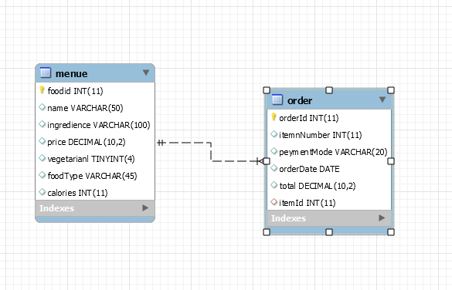

**First Window:**

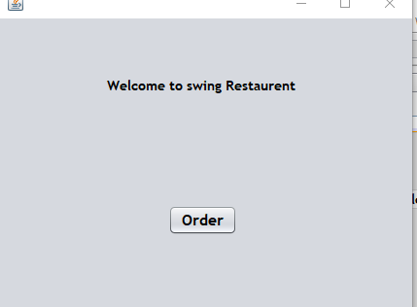

**Second Window:**



**Third Window:**

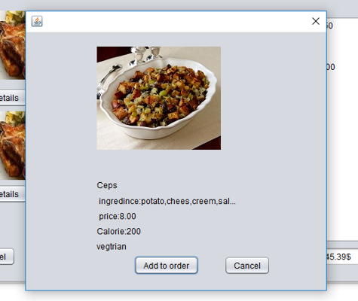

**Fourth Window:**

